**WARSAW UNIVERSITY OF TECHNOLOGY**

Faculty of Power and Aeronautical Engineering

*“Czapla”*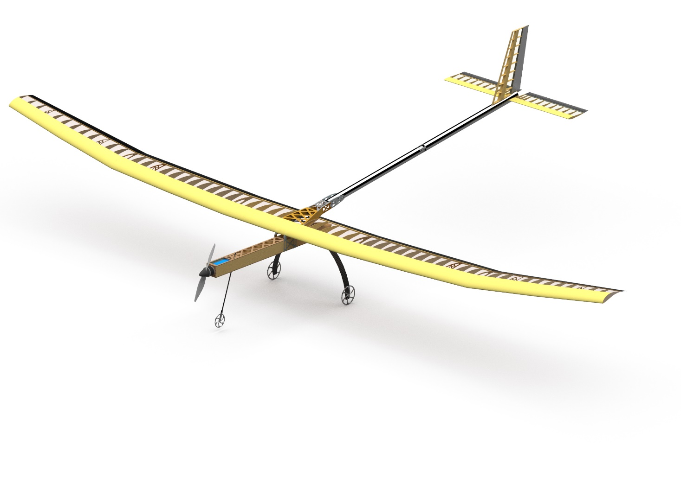**Design report of a cargo model aircraft**  
SAE Aero Design East 2023  
WUT Regular  
Team number: 035

Team Members: Michał Włodarczyk, Antoni Szczurko, Bartosz Zięzio,   
Maciej Kupras, Monika Mederska, Julia Lesiuk

# Table of Contents

Table of Contents - 3 -

Table of Figures - 4 -

Table of Tables - 4 -

Table of Symbols and Acronyms - 4 -

Table of References - 4 -

1. Executive Summary - 5 -

1.1 Introduction and key objectives - 5 -

1.2 Discriminators - 5 -

2. Project overview - 5 -

2.1 Schedule and plans - 6 -

2.2 Resources and costs - 7 -

2.3 Risk analysis, test flight, validation - 8 -

3. Design Layout and Trades - 8 -

3.1 Scoring analysis - 8 -

3.2 Design process - 9 -

3.2.1 Initial design and vehicle configuration selection - 9 -

3.2.2 Fuselage, cargo bay and landing gear - 11 -

3.2.3 Wing design - 11 -

3.2.4 Airfoil selection - 12 -

3.2.5 Tail design - 13 -

3.2.6 Mass and balance - 14 -

3.2.7 Propulsion selection - 14 -

3.2.8 Vehicle sizing and servo selection - 15 -

3.2.9 Structural analysis, loads, and material selection - 16 -

3.2.10 Spar wall structure and testing - 17 -

3.2.11 Wing static test - 17 -

3.3 Final structure design - 18 -

3.3.1 Assembly - 18 -

3.3.2 Design features - 19 -

4. Performance Analysis - 19 -

4.1 General - 19 -

4.2 Weather conditions - 20 -

4.3 Take-off and climb analysis - 20 -

4.4 Stability and control - 22 -

4.5 Turn radius analysis - 23 -

4.6 Polar curve and landing distance - 23 -

4.7 Payload prediction and lifting performance - 24 -

5. Manufacturing - 24 -

6. Conclusions - 25 -

7. Appendices - 26 -

# Table of Figures

|  |  |  |  |  |  |  |  |  |  |  |
| --- | --- | --- | --- | --- | --- | --- | --- | --- | --- | --- |
| |  |  |  | | --- | --- | --- | | Fig. 1 | – |  | | Fig. 2 | – |  | | Fig. 3 | – |  | | NUMERY STRON |

# Table of Tables

|  |  |  |  |  |  |  |  |  |  |  |
| --- | --- | --- | --- | --- | --- | --- | --- | --- | --- | --- |
| |  |  |  | | --- | --- | --- | | Tab. 1 | – |  | | Tab. 2 | – |  | | Tab. 3 | – |  | | NUMERY STRON |

# Table of Symbols and Acronyms

|  |  |  |  |  |  |  |  |  |  |  |  |  |  |  |  |  |  |  |  |  |  |  |  |  |  |  |  |  |  |  |  |  |  |  |  |  |  |  |  |  |  |  |  |  |  |  |  |  |  |  |  |  |  |  |  |  |  |  |  |  |  |  |  |  |  |  |  |  |  |  |
| --- | --- | --- | --- | --- | --- | --- | --- | --- | --- | --- | --- | --- | --- | --- | --- | --- | --- | --- | --- | --- | --- | --- | --- | --- | --- | --- | --- | --- | --- | --- | --- | --- | --- | --- | --- | --- | --- | --- | --- | --- | --- | --- | --- | --- | --- | --- | --- | --- | --- | --- | --- | --- | --- | --- | --- | --- | --- | --- | --- | --- | --- | --- | --- | --- | --- | --- | --- | --- | --- | --- |
| |  |  |  | | --- | --- | --- | | AR | – | Aspect Ratio | | CAD | – | Computer Aided Design | | CG | – | Center of Gravity | | CL | – | Lift coefficient | | CLmax | – | Maximal lift coefficient | | CNC | – | Computer Numerical Control | | FFS | – | Final Flight Score | | Fig. | – | Figure | | FOS | – | Factor of safety | | FS | – | Flight Score | | L/D | – | Lift to Drag ratio | | MAC | – | Mean Aerodynamic Chord | | MO | – | Gross Weight | | MTOW | – | Maximum Take – Off Weight | | ReMIN | – | Reynolds number corresponding to stall speed | | TNOM | – | Nominal torque | | TO | – | Take – Off | | TR | – | Taper ratio | | TR | – | Taper Ratio | | VC | – | Cruise speed | | VD | – | Diving speed | | WS | – | Wingspan Score | | WUT | – | Warsaw University of Technology | |  |

# Table of References

|  |  |  |  |  |  |  |  |  |  |
| --- | --- | --- | --- | --- | --- | --- | --- | --- | --- |
| |  |  |  | | --- | --- | --- | | [1] | – | Fixed-wing unmanned aerial vehicle wing design (Engineering Thesis); Piotr Pacuszka | | [2] | – |  | | [3] | – |  | |

# Executive Summary

## Introduction and key objectives

WUT SAE Aero Design Collegiate Club hereby presents 2023 Regular class aircraft, “Czapla”. The main goal of the SAE AeroDesign 2023 competition is to design an aircraft with short take-off distance, as well as the greatest possible wingspan and payload capability. This year's strategy is based on maximizing WS bonus points, therefore we assumed monoplane wing configuration with 216 in wingspan. The main goal was to maintain a simple structure, time-saving manufacturing and fast cargo unloading. By optimizing aerodynamics and structure design, the plane is expect to lift xxxx payload.

## Discriminators

Our airframe has a conventional configuration with wing divided into five sections and single half split tail boom to meet single part dimension requirement. High aspect ratio reduces induced drag. Extended stability analysis resulted in a polyhedral wing that significantly improves spiral stability for a more enjoyable flight experience. Cargo bay is located in the fuselage below center wing. Aircraft was designed to simplify operations at the field and for easy maintenance.

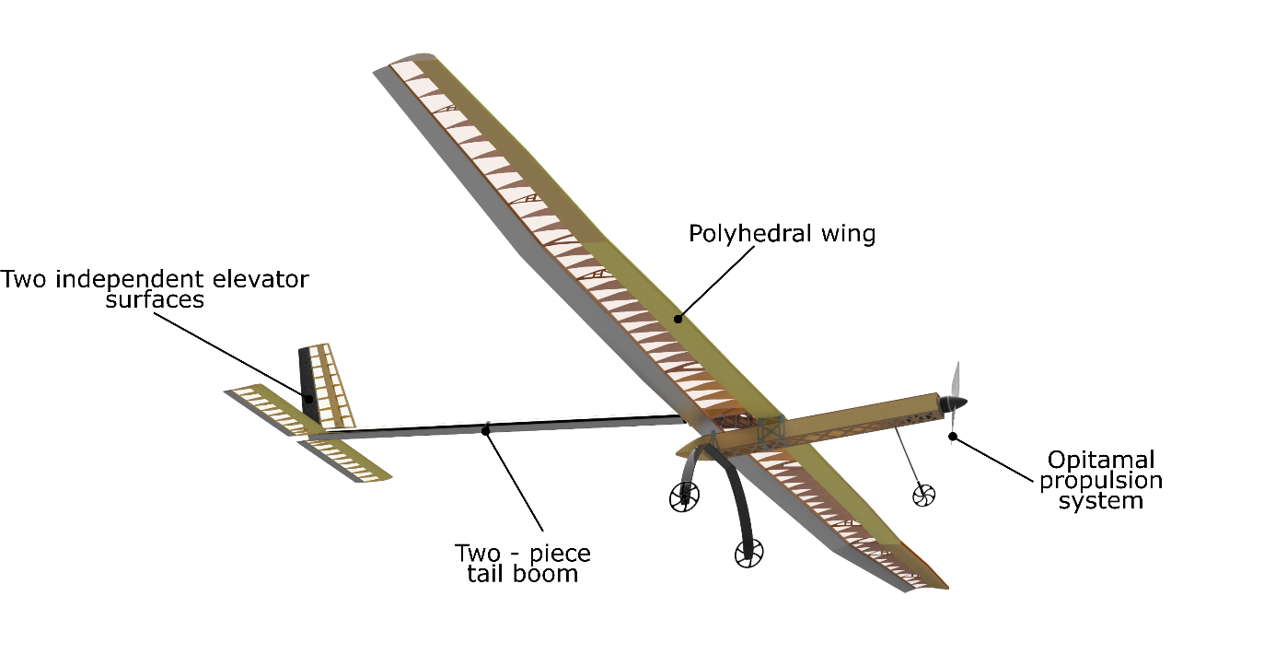  
Fig. 1

*dodać tabelkę z najważniejszymi danymi – rozpiętość, długość, pow. nośna etc*

# Project overview

In this year's edition of the competition we decided to participate in two classes – Regular and Micro. Each class has  
its coordinator and vice – coordinator who is responsible for designing and manufacturing the aircraft. Using the experience from previous editions, we significantly increased work efficiency and management techniques in the SAE AeroDesign Warsaw Student Association. Due to the timing of the publication of the regulations, we had to design and build the aircraft within 6 months. We set ourselves the ambitious task of building the largest aircraft in the history of our association. We based our communication on MS Teams and OneDrive. It improved the connection between team members, especially designers and CNC operators. Moreover, we used ClickUp app to track schedule and work progress. During design process we used XFLR5 and AVL for aerodynamics and stability design, XoptFoil for airfoil design, MATLAB and MS Excel for optimization and Siemens NX for structure design. Most of the aircraft parts were manufactured in our workshop at the University. We have used wind tunnel at our faculty for propulsion selection and tests.

## Schedule and plans

We started to work on strategy analysis as soon as new rules were released. During the first three weeks, we conducted initial optimization, which led to a decision for the classic configuration with maximum wingspan. By the end of September, we performed initial propulsion system test to gain data required for take-off and climb performance analysis and for the final configuration selection. Simultaneously, we carried out material strength measurement of wooden structures. We started manufacturing wing and tail boom in the last week of November. We divided the workshop work into individual subsections, and each was headed by a person responsible for a given aircraft component. This way of organization significantly improved the efficiency of the aircraft manufacturing. To reduce external expenses, we decided to manufacture simple parts on our CNC router. Third-party companies manufactured complex components such as tail boom adapters. The team met once a week to track the progress in work done and divide new tasks. A more detailed schedule is presented below in figure no. 5.

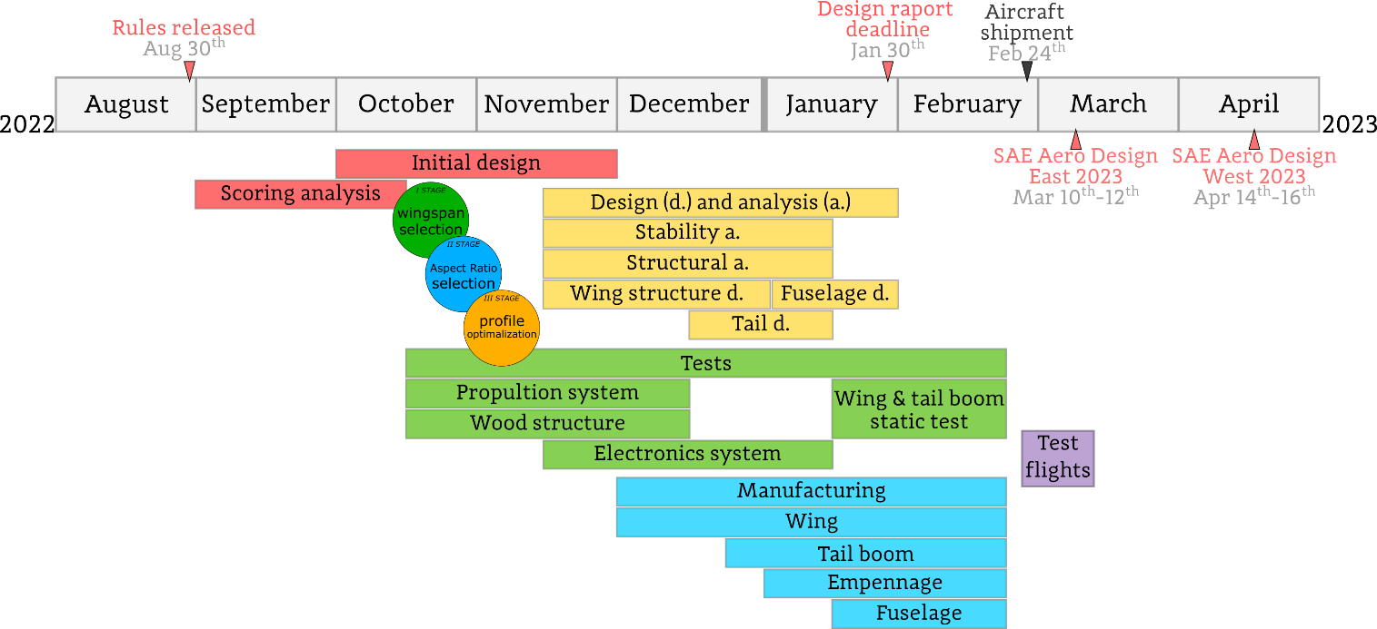

## Resources and costs

Main challenge in this edition was to design and manufacture planes for regular and Micro class within six months. Thanks to the funding received from sponsors and institutions such as the University or the Ministry of Education and Science, we could afford to build an aircraft with 216 in span. Most of our aircraft is made with balsa, plywood and aviation aluminium alloy to obtain material restrictions. An important factor we had to consider this year was the availability of balsa wood in Europe. During previous years we selected each balsa’ plank to find those which matched our specification. This year, we had to accept large variances between individual sheets, as we could not hand pick the ones we wanted. This limited us in terms of reducing the mass of the structure. The relatively large differences between strength related to density were considered during structure design process. Moreover, to reduce costs and increase the time efficiency of production, we decided to make most of the elements ourselves. Only in exceptional cases requiring high accuracy and special equipment we outsourced machining to third party companies. As we planned to participate in SAE Aero Design East and West we carefully planned budget for aircraft manufacturing and travel knowing the rising cost of supplies, and travel related costs.

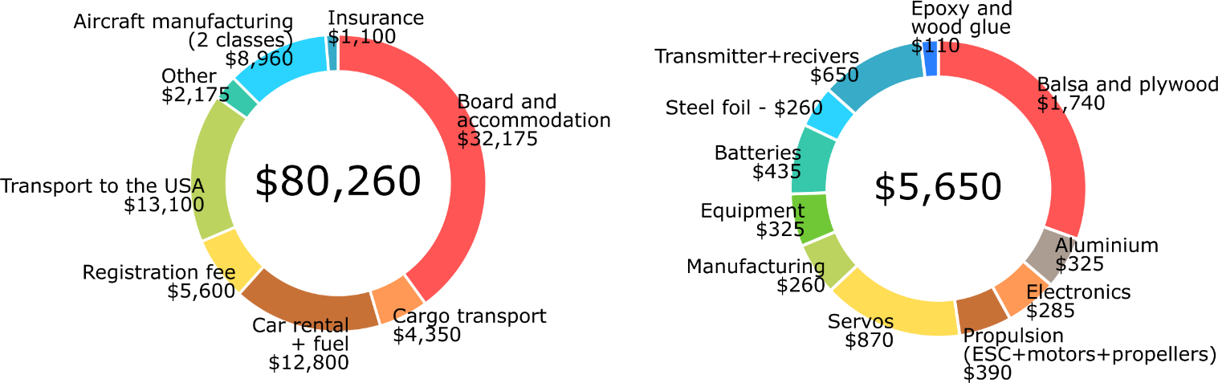

## Risk analysis, test flight, validation

Safety is critical in the design of the aircraft, especially due to the size of our plane. This required careful analysis of risks and potential issues in various areas. Firstly, we performed the analysis with the usage of safety factors on different components. To increase our understanding of balsa mechanical properties, we conducted strength tests, that gave us precise data used in the design phase. As we decided to participate in both SAE Aero Design editions - East and West, we designed our plane for expected weather conditions in Texas in the middle of April. Conditions will be more challenging than in Florida, with lower air density and stronger wind gusts, according to climate data. We will perform a static test of the wing and tail boom to verify structure reliability with 100% assumed load. We decided to build a training wing with a simple, robust and easy to repair structure for tests and for practice for our pilot.

The reliability of high-quality electronic components were also tested under expected load. Moreover, we divided electronics into quick-to-replace modules to limit the maintenance time at the field, understanding risk of failure due to faulty component, weather condition or human error. In case of serious problems, we have compatible replacement modules with components from different manufacturers. As testing will not eliminate the risk of electronics failure, we implemented parallelly working receivers, separate battery pack for receiver, servos and redundant control surfaces of ailerons and elevators

# Design Layout and Trades

## Scoring analysis

Analysis of the scoring rules showed the crucial role of wingspan, payload and structure mass in determining the FFS. We started initial design with comparison of possible configuration. Firstly, we rejected tailless configuration, both delta and flying wing., due to disproportionate time required on stability analysis and test flight, compared to potential profit. Biplane and triplane configurations were rejected due to low experience with such designs and expected low directional stability that can be very dangerous in windy conditions. Therefore we decided to analyse scoring for classical monoplane configuration. Because of many possible aircrafts planform designs we decided to perform calculations comparing performance and expected FFS of monoplane with wingspan between 120 in and 216 in. We prepared program that estimated basic parameters such as aircraft parts mass basing on wingspan and wing surface. It was based on ours previous years designs. We estimated also fuselage and empennage drag, as well as landing gear parameters in order to increase the accuracy. An analysis of take – off and climb performance was performed on more than fifteen wing designs with different span and aspect ratios, and found that maximizing these parameters produced the best results. In the end, we decided to select a 216-inch wingspan, and XXX surface giving a score of X pounds payload what results in ( wypisać FS, FFS, WS…)

## Design process

### Initial design and vehicle configuration selection

Decision to design aircraft in classic monoplane configuration led us to divide the optimization process into three steps: wingspan selection, AR selection with fixed wingspan and profile optimisation. Below fig xxx shows the scheme and main assumptions for each stage.

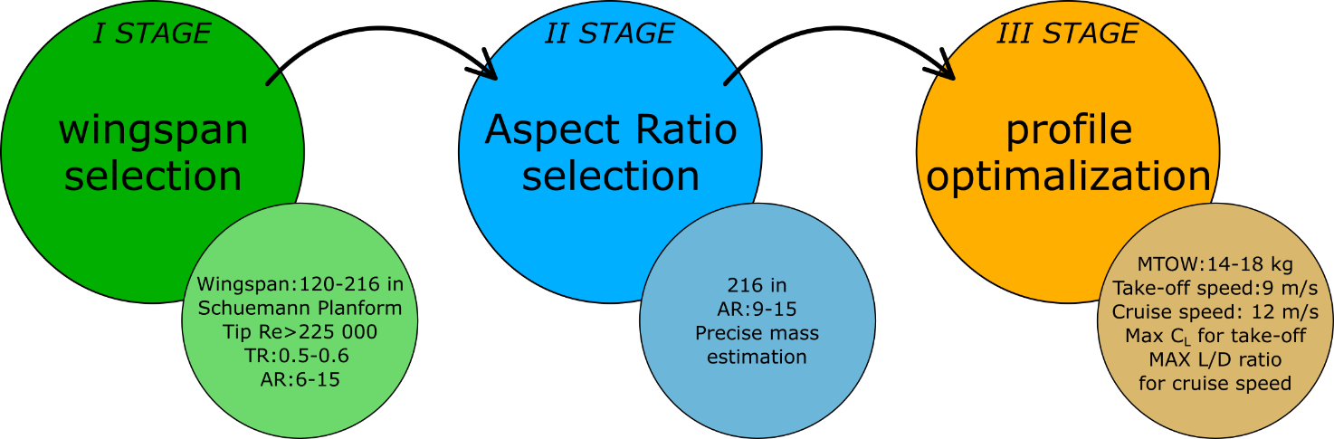

The main objective of the initial analysis was to find the balance between wingspan (greater wingspan - higher empty mass) and payload lifted. For this reason, we developed a simulation of take-off and performance during the climb using MATLAB software. We compared multiple wingspan and aspect ratio configurations, with approximated structure mass. In XFLR5 software we analysed aerodynamic performance. For each wing we used LR315 airfoil developed in our association for regular class in 2019. Assumed limitations were: take-off distance assumed 400 ft/min minimum climb rate (safety of flight) and cruise speed. The final output of these calculations was MTOW, payload and FS for each configuration As a result, we decided to design the aircraft with a maximum wingspan. fig xxx plots a comparison of expected FFS for considered AR and wingspan range.

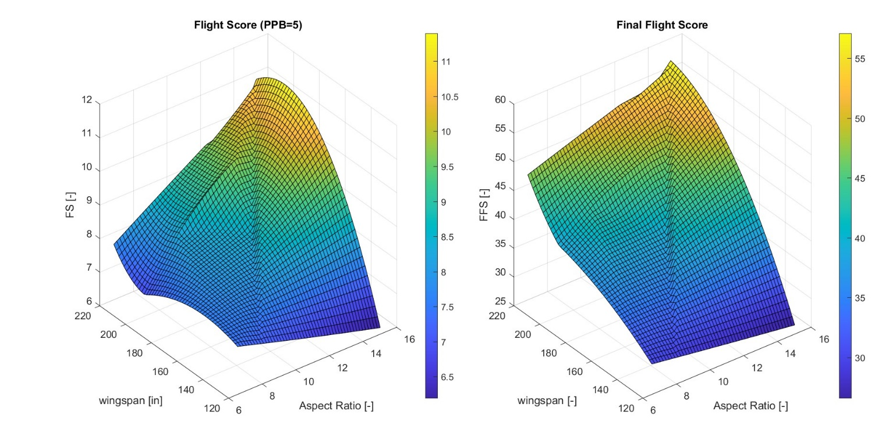

Wykres- zbocze, obrazzek z rozważanym obrysem???

During the second stage of optimization, we decided to compare the wing's performance with 216 in wingspan and aspect ratio between 8 and 15, corresponding to surface of 40 ft2 and 21,5 ft2. Based on analysis results, we could expect higher FS with higher AR, however it would result in lower Re number on the wingtip (smaller tip chord) and heavier structure. We used similar methodology, with additional consideration of the wind during take-off. Below in fig is shown result of final optimization.

For each configuration without wind, the TO distance was our limitation. Headwind greater than 10 ft/s limits the MTOW with an assumed minimum climb rate. Since we expect windy conditions in Florida and Texas, we decided on a 216 in wingspan and an AR15, which provides the greatest payload with the expected minimal wind.

### Fuselage, cargo bay and landing gear

The aircraft fuselage primarily intends to carry the payload, propulsion system and the necessary electronics for flight. In addition, the fuselage location relative to the wing was selected to ensure proper stability. Moreover, we were determined to simplify the construction of a fuselage that would be easy to make and repair.

As for landing gear, we decided on three-point landing gear, with the front landing gear equipped with a shock absorber and commercially available carbon fiber landing gear to reduce mass and provide enough amortisation to minimize the risk of damage to the aircraft during take-off and hard landing. Due to the long tail boom, we were obliged to choose high landing gear to prevent tail strike.

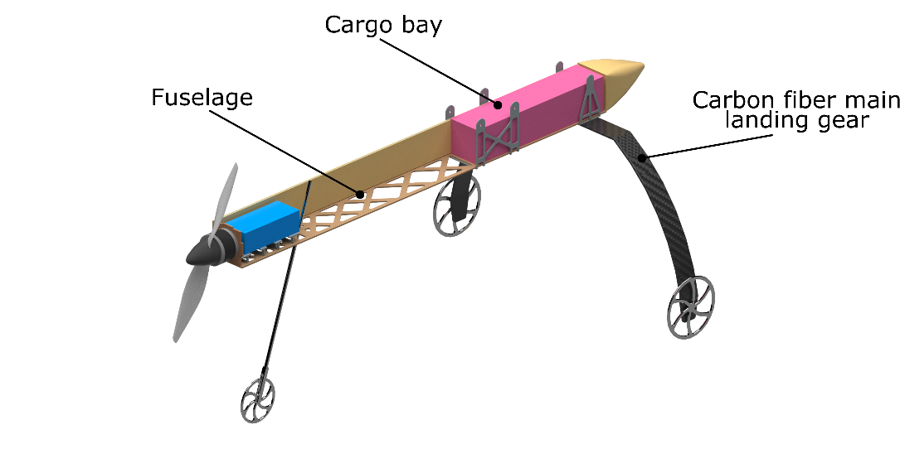

### Wing design

After second stage of optimization we decided to use 216 in wingspan and 15 AR. We assumed TR between 0.5 – 0.6 to achieve optimal lift distribution along wingspan to reduce spar mass. The next step was predicting the achievable speed of the aircraft at the end of take-off roll, basing on tested propulsion performance. Using previously mentioned MATLAB script for take-off analysis and measured propulsion performance, we predicted the take-off speed to be 29.5 ft/s for MTOW = 16kg. We assumed 23.33 kts cruise speed, which is 1/3 higher than stall speed . Our experience with similar airframes from previous competitions suggests that the ReMIN value should be no less than 225 000. These conditions, paired with the wingspan set to 216 in during optimization, led us to wing 16.3 in root chord, 10 in tip chord and 14.6 in MAC.

The wing was divided into multi-trapezoidal segments to obtain a half-elliptical outline, which was chosen to lower induced drag. A straight trailing edge minimalizes 3D flow behind the wing [1]. This year’s maximum part dimension restriction rule forced us to divide the wing into five sections, each of equal wingspan. Dihedral was applied to mid-and outer sections to improve the spiral stability (described in section [XXX]). The ailerons were divided into three sections for better steering efficacy and redundancy.

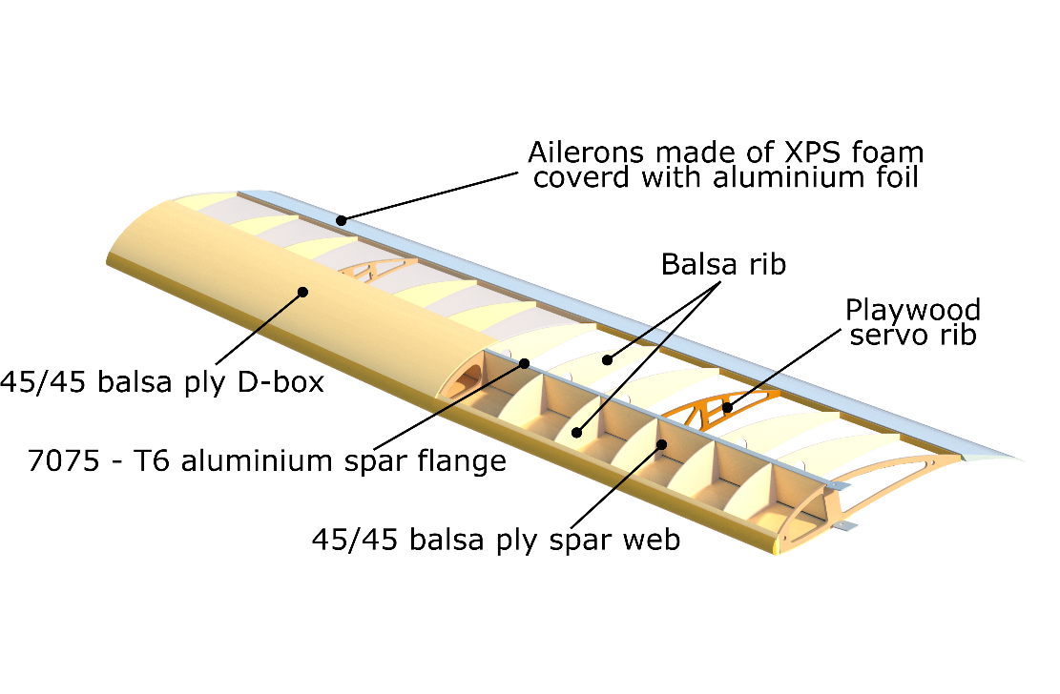

Rysunek przekroje i skręcenia

### Airfoil selection

As mentioned in 3.2.1 third stage of wing design was airfoil optimization. Although this year’s aircraft is similar to our 2017-2019 designs, the airfoil LR315 from 2019 used in initial optimization was not perfectly suitable for the 2023 Regular class mission and our wing design. Therefore, the team modified it and developed three new airfoils (MW 01.203, MW 01.202 and PP02) using Xoptfoil software. All three had a requirement of a minimum 13% thickness due to structural conditions. The center wing airfoil (MW 01.203) had a priority of high L/D ratio. The wingtip airfoil (PP02_mod2) provides high ClMAX to avoid wingtip stalls first. It differs significantly from MW 01.203 (mainly because of higher camber), so the third airfoil (MW 01.202) was designed to allow for a smooth transition between them. In the outer sections geometric twist is applied to achieve good stall characteristics. To ensure there will be no early flow separation on the wingtip, we plan to conduct wind tunnel testing of this section and, if necessary, install a vortex generator.

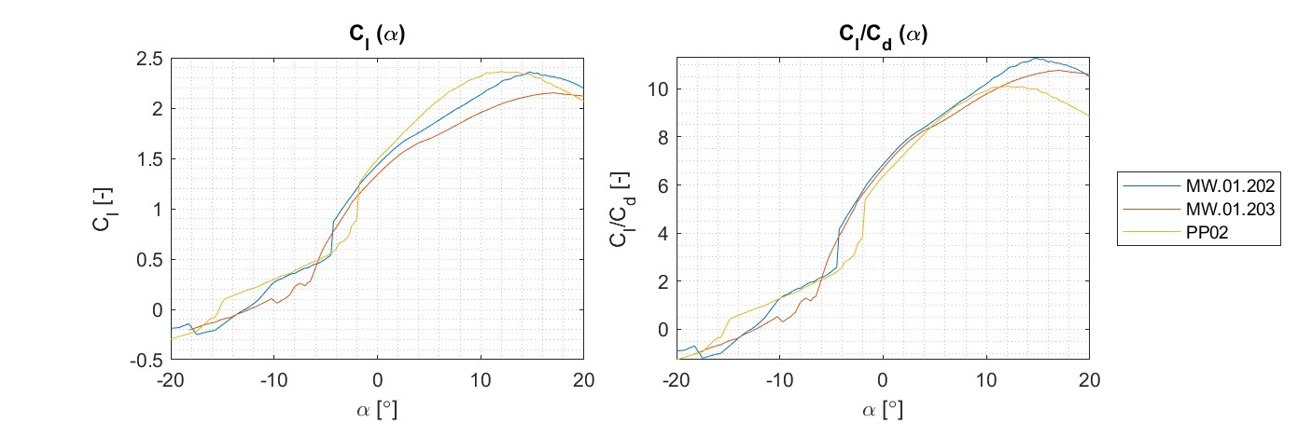   
[trzeba powiedzieć jeszcze o skręceniu] // [zdjęcia profili, wykresów dla profili, jak jest miejsce to skrzydła z podpisanymi profilami] // Tabelka ze współczynnikami bezpieczeństwa

### Tail design

As we decided on 216 in wingspan, it was crucial to analyse the manufacturability of the tail boom before the second step of optimization. We realized that one piece tail boom, shorter than 48 in (due to rules) would not provide simultaneously satisfying stability and performance. Longer tail boom requires splitting it into two or more sections and requires stiffer and stronger booms. Twin tail boom configuration would significantly complicate the structure of the wing/fuselage and also result in heavy tail configuration. We decided on half splited, single boom empennage. The sizing factor for tail boom was deflection, not solely its ultimate strength. We assumed a maximum of 2 deg deflection at 75% of the maximum force within the flight envelope to prevent tail from swinging in windy conditions. That resulted in roller shaped boom with a constant 2.13 in. diameter. We designed lightweight CNC machined aluminium tail boom joints enabling disassembly of the boom into elements shorter than 48 in. To reduce mass, drag and simplify structure, we decided for T – tail empennage, with horizontal stabilizer mounted directly to the tail boom. In fig below is shown CNC milled tail boom joint and considered tail configuration.

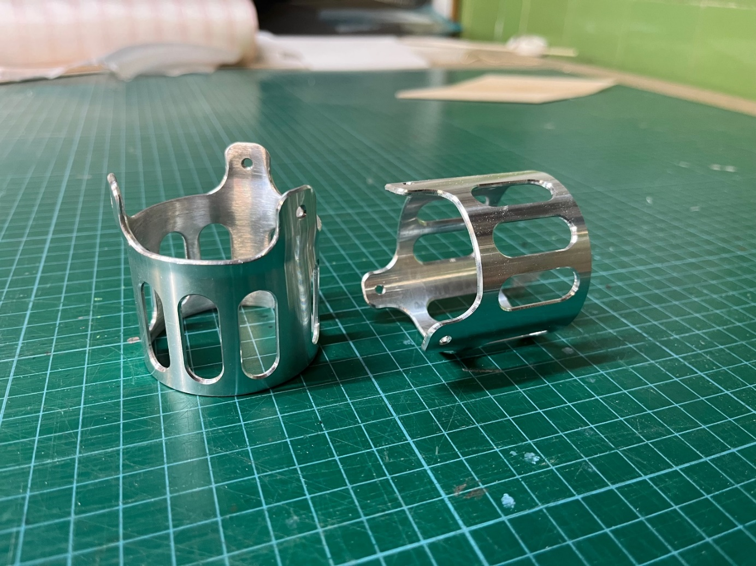  
Obrazek porównujący podwójną belunię I pojedynczą i zaznaczenie łączeń // Obrazek z adapterami wykonana belunia?

### Mass and balance

We calculated the MEMPTY of the aircraft by assigning proper density values for each part of the CAD model prepared in NX software. For manufactured parts, we multiplied the weight by factor 1.15 to include the mass of the glue weight. The empty weight was then used in scoring analysis to calculate the maximum possible payload. We also performed a balance analysis to ensure the proper location of CG.

|  |  |  |  |  |
| --- | --- | --- | --- | --- |
| No. | PART | MASS [Lb] | X [ft] | Moment of cg [lb-ft] |
| 1 | Wing | 5,51 | -0,03 | -0,170 |
| 2 | Horizontal tail | 0,51 | 6,95 | 3,525 |
| 3 | Vertical tail | 0,44 | 7,17 | 3,160 |
| 4 | tailboom | 2,09 | 3,01 | 6,312 |
| 5 | fuselage | 1,43 | -1,48 | -2,122 |
| 6 | Main gear | 0,88 | 0,23 | 0,199 |
| 7 | Front gear | 0,55 | -2,40 | -1,323 |
| 8 | Motor | 0,79 | -2,96 | -2,347 |
| 9 | Aileron servos | 0,20 | 0,00 | -0,001 |
| 10 | Elevator servos | 0,07 | 7,02 | 0,464 |
| 11 | Rudder servo | 0,03 | 7,18 | 0,237 |
| 12 | Propeller | 0,31 | -3,06 | -0,943 |
| 13 | Main battery pack | 1,65 | -2,40 | -3,968 |
| 14 | Reciever | 0,44 | -0,10 | -0,045 |
| 15 | Servo electronic pack | 0,26 | -0,20 | -0,053 |
| 16 | ESC | 0,26 | -0,20 | -0,053 |
| 17 | Red arming plug | 0,44 | -0,82 | -0,364 |
| 18 | Ballast | 0,32 | -2,89 | -0,924 |
| I | M empty | 16,20 | 45.06 % MAC | |
| 19 | PAYLOAD | 17,64 | -0,09 | -1,584 |
| II | MTOW | 33,84 | 37.03 % MAC | |

### Propulsion selection

Using previous years' experience and recognizing the maximum power as 750 W, we decided to use the Mn 605 320 kV motor for wind tunnel testing. After a preliminary propeller performance analysis, we decided to statically and dynamically test seven propellers from APC and Mejzlik companies, with diameters ranging from 21 to 30'' and pitch from 10 to 12'' (Figure X). Ultimately, we decided on the APC 21x12 propeller, which, despite having less static thrust (9,5 lbf), provided the greatest dynamic thrust (7,5 lbf) for a cruising speed of v=23.33 kts.

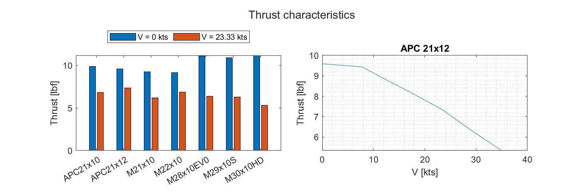

### Vehicle sizing and servo selection

The dimensioning of the aircraft was taken into account throughout the design process. Scoring analysis and optimization were used to dimension the plane. In addition, using experience from previous years, we were able to determine the size of the fuselage and the necessary undercarriage to withstand landing overloads. In order to ensure adequate control, the dimensions and hinge moments of the control surfaces were calculated with the XFLR5 program (using the VLM1 method) and further confirmed by calculations using basic flight mechanics methods. The analysis was performed for a speed of VD= 35 kts. Resulting hinge moments, assuming a control surface is a single panel, are presented in the table below.

The aircraft uses 9 servos of the same type, of which 6 control the ailerons, 2 control the elevators, and one controls rudder. We decided to use the SAVox SV-0250MG servos proven in previous years (TNOM=69.44 oz ∙ in).

### Structural analysis, loads, and material selection

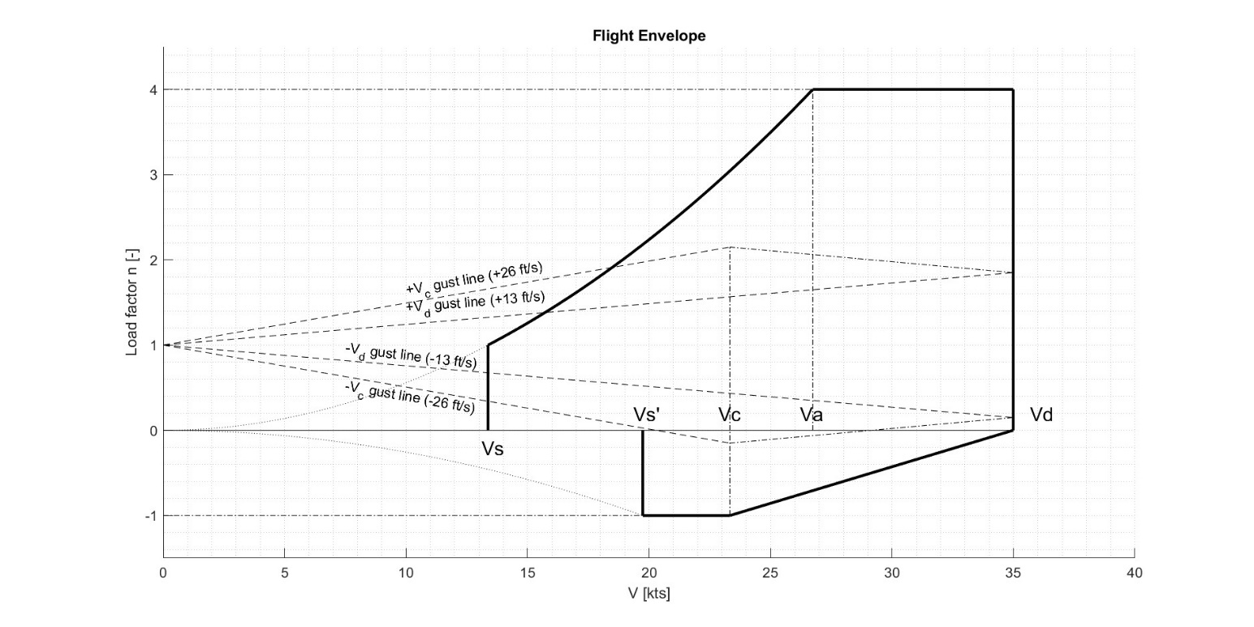

We designed the aircraft according to CS-23 requirements. Structural calculations were based on flight envelope calculated for expected weather conditions. As mentioned before, we participate in SAE Aero Design East and West. In the middle of April in Texas we expect harsher weather conditions- stronger wind, higher temperature and lover air density. Basing on climate analysis and flight speed range maximum load factor was assumed to be +4 and -1. Design cruise speed was 23.33 kts (VC). Due to expected strong wind and gusts we assumed the diving speed (VD) as 38.9 kts.

We decided to use 1.5 safety factor for all the aluminum parts of the wing spar. The FOS of the balsa structure was determined as 2.5, basing on the {wstawioć przypis cyferkowy do źródła} due to wide range of balsa wood properties according to the paper "Study of the spar wall structure of the 'Regular' class unmanned aircraft for the SAE Aero Design 2022 competition". According to the measurements made with PixHawk during flight tests in previous years, the landing shock is approximately -2.5 g. For other parts of the aircraft, we used a safety factor of 1.25. The strength-to-weight ratio was an important criteria in material selection, as well as cost and availability of materials.

Basing on flight envelope, we calculated loads in spar and D-box. We selected aluminum alloy 7075-T6 for the spar flanges, because of high yield strength, low density and easy manufacturing. Spar flanges geometry was calculated basing on lift distribution. D-box was made of 2-layer balsa plywood (0.06 in on the center wing, 0.03 in at the wing tips) with -45/45 grains orientation. To reduce the mass of spar wall and prevent from buckling, we made a sandwich structure of 2-layer balsa with PVC foam (Herex) between them. Higher loaded ribs were made out of plywood. The other ribs were made of balsa to reduce the weight of the wing. To provide good airfoil representation the ribs were laser-cut or milled on a CNC machine. Wing, fuselage and empennage is covered using OraLight foil to achieve smooth surface and low mass.

Renderek z opisem struktury płata

As mentioned in xxx tail design, the tail boom deflection was the dimensioning criterion. To meet this requirements tail boom was made of two layers of steel foil (0.002 in) and balsa wood (0.08 in) between them. This year, because of the requirements of the regulations, the tail boom of our aircraft is made of two parts. In order to assemble and dismantle the aircraft efficiently, we designed the joints CNC machined from 7075 aluminum alloy.

### Spar wall structure and testing

A detailed theoretical analysis of the strength of the wing wall under shear force allowed to reduce spar mass by redesigning the structure. The limiting factors for the spar are its strength and the risk of buckling. We changed the balsa panel structure used in previous editions to a sandwich structure consisting of two balsa planks and PVC-Herex foam to increase the moment of inertia. Material tests were carried out in a double articulated frame, which operates in pure shear under the transmission of forces through its perimeter. Spread of ultimate strength was 16,9% what is acceptable comparing to 15,4% in [wstawić źródło o balsie]. Understanding risk of error during manufacturing, we decided for 2.5 safety factor for calculations of spar wall structure.

Obrazek z testów ściany dźwigara

### Wing static test

To verify our calculations and the reliability of the structure, we are going to conduct conducted static tests of the wing. We will perform performed a test for 100% of the maximum bending loads in flight, achieved at point A of the flight envelope. Fig. X shows the bending moment distribution along the wing span at point A of the flight envelope. 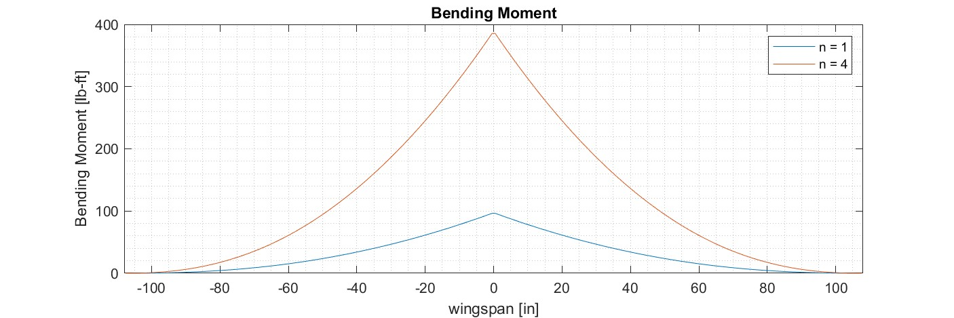

The wing will be progressively loaded with weights distributed along the wing span during the test. We will measure the deflection of the wing tip for an increasing load and compare it with the calculated deflection. We will also observe whether there is any damage to the wing structure.

The planned end of the wing's building is early February. At that time we intend to conduct static tests, and for this reason, we cannot yet include photos of the tests and their results.

## Final structure design

### Assembly

In order to allow transport in a container and fulfill the requirements of the regulations, the aircraft is divided into 12 main parts. The connections between the parts are designed to make assembling and disassembling the aircraft comfortable and quick. As a result, preparing the aircraft for flight takes little time and does not create additional difficulties.

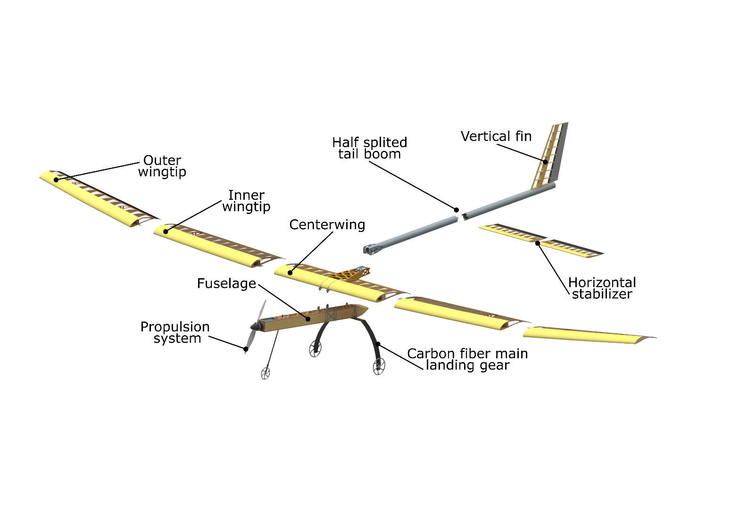

### Design features

The most challenging part of our aircraft, both in design and manufacturing, is the five part wing, which parts are connected to each other with only one bolt each. This allows the aircraft to be quickly assembled and ready for flight on the runway.

The tail boom of our aircraft consists of two parts, which are connected to each other with adapters designed by us. In order to easily connect and disconnect electronic devices in our aircraft, we have provided a separate space for them.

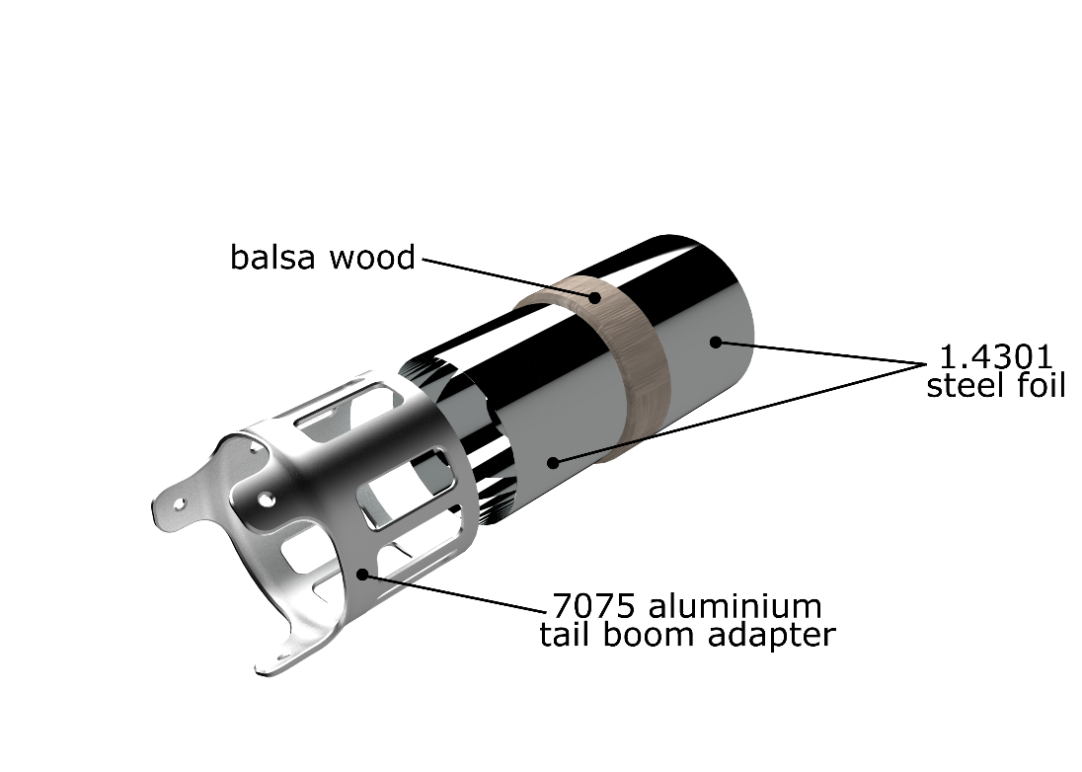1

# Performance Analysis

## General

The performance analysis was carried out to verify the accuracy of the initial design assumptions and to anticipate and prevent potential risks during the flight.

We divided the flight into the following phases:

* pre-flight weather conditions,
* take-off and climb analysis-Analysis of take-off distance and climb speed,
* stability and control- Analysis of dynamic stability and roll controllability ,
* cruise speed - turning radius analysis,
* descent and landing-Analysis of polar curve and landing distance.

As a result, we were able to make a payload prediction.

## Weather conditions

We analyzed weather conditions to predict air density and collected information on wind direction and speed based on climate data. The wind is predicted to blow at East and North direction at an average speed of 6.7 mph and gusts up to 13.2 mph.

dopisać

|  |  |  |  |  |  |  |
| --- | --- | --- | --- | --- | --- | --- |
| Elevation | Avg. high temp. | Pressure | Avg. wind speed (10 AM-4 PM) | Max. gust wind | Wind direction | Air density |
| 194 feet |  | 30.09"Hg | 11.6 mph | 15.2 mph | 28% east  27% north |  |

## Take-off and climb analysis

To analyse TO and climb we developed MATLAB application to estimate aircrafts performance. Limited power and take off distance require to precisely simulate take-off ground roll including rotation phase to not exceed the take-off distance and each appropriate speed before the transition phase For accurate simulation, each phase was simulated by determining the forces and moments acting on the on the aircraft (shown in Figure X).

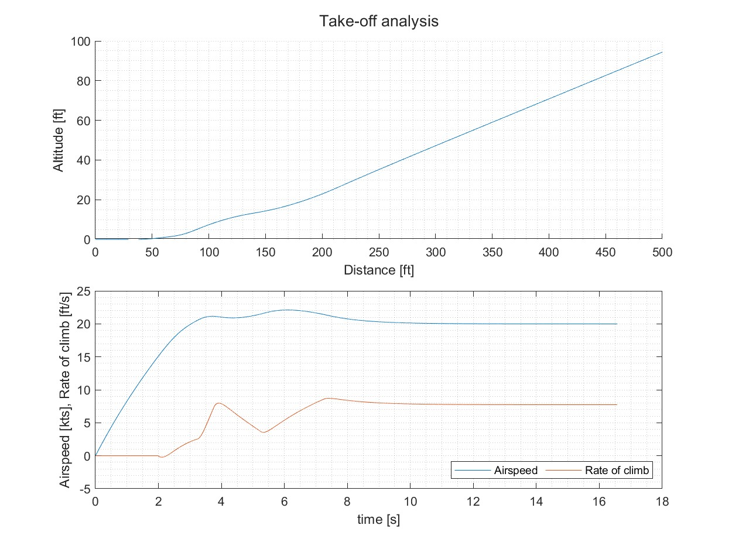2

A climb rate analysis was made to ensure that the aircraft can reach safe altitudes margin over obstacles to perform a turn. According to our assumption, the climb rate should exceed 7 ft/s .

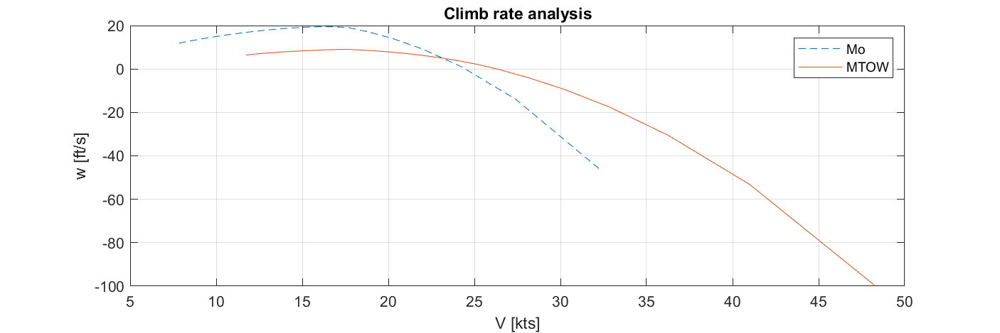3

## Stability and control

Stability was analyzed according to the CS-23 regulations using Panukl and SDSA- software developed at our faculty. First step was to calculate static stability to size up empennage and reach 20% stability margin for TO weight for speed range from 17.5 kts to 31.1 kts Second step was dynamic stability analysis using moments of inertia obtained from mass and balance analysis. We ensured that any combined lateral–directional oscillations will be damped to at least 1/10 in 7 cycles. Additionally polyhedral wing significantly improved spiral stability. Final results were compared using XFLR5 software with no significant differences. Furthermore, we conducted roll analysis to meet the requirements of turn radius. Results showed that ailerons on 3/5 of the wingspan with deflection (+15°/−25°) provide enough angular roll velocity.

Napisać coś jakie wartości udało się osiągnąć

Obliczenia stateczność I sterowności a także ruchów fugoidalnych

## Turn radius analysis

Considering the equations od rotational motion we calculated the turn radius in relation to the bank angle. The chart below shows that at the speed of 24 kts and the bank angle of 10 degrees that the aircraft performs a turn with the radius of 300 ft. This ensures the flight within available space.

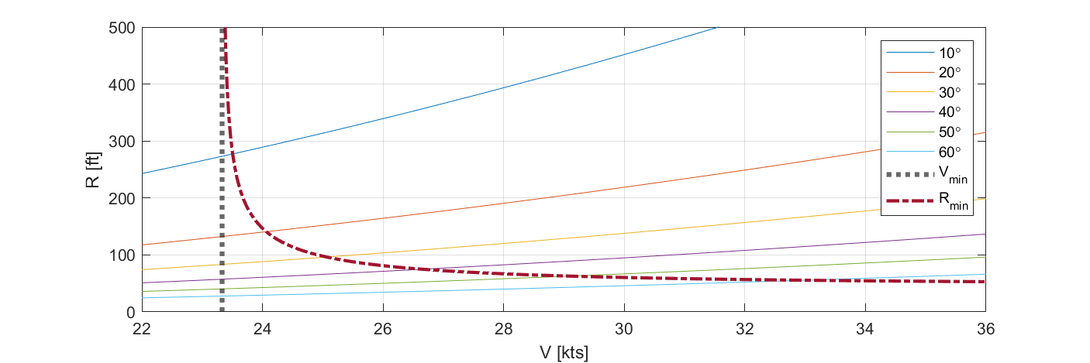4

## Polar curve and landing distance

A polar curve was made for the landing analysis (Figure X). The best descent angle (2.38°) was obtained for an aircraft with a full load (MTOW=27.5 lbs) and a speed of 18 kts at the start of the descent.

Using this analysis and assuming an altitude of 34 ft at the beginning of the descent, we prepared a distance analysis for 4 phases: descent, flare, touchdown, and after-landing roll. The results (Fig. X) allowed us to determine the 180 ft reserve needed to land at the 400 ft required by the competition rules.

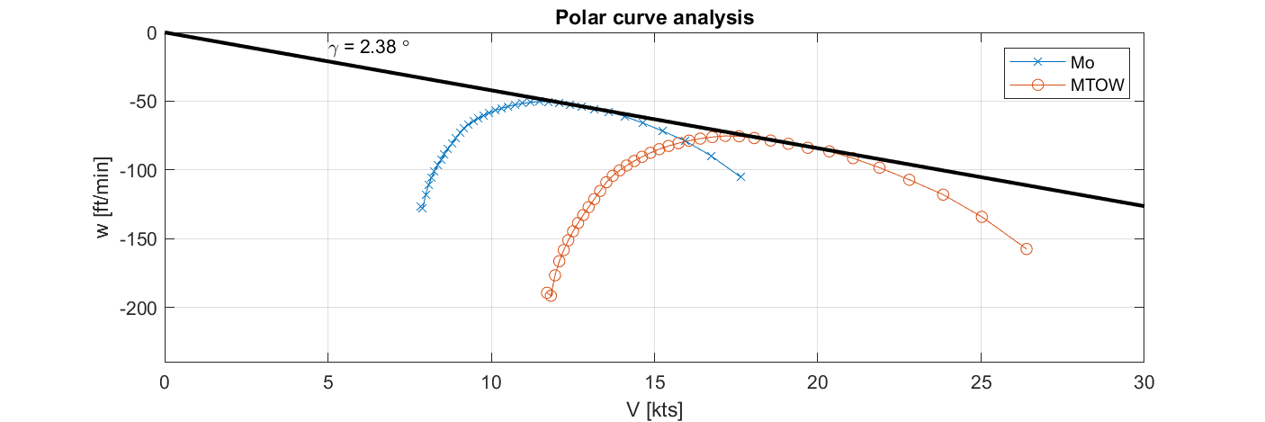5

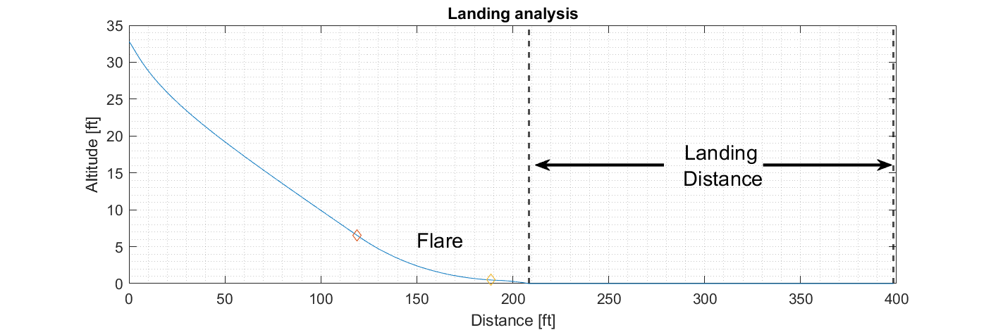

## Payload prediction and lifting performance

The load prediction curve (Appendix 1) was created from the performance analysis with the following assumptions:

* the calculated take-off distance should not exceed 70 ft,
* the rate of climb should not be less than 7 ft/min,
* descent speed not less than 80 ft/min,
* radius of the turn not greater than 300 ft,
* landing distance not greater than 180 ft,
* wind is not taken into account.

# Manufacturing

For the construction of the plane, we used mainly balsa wood, which has the best strength-to-weight ratio. Due to regulations, we are not allowed to use composite materials. We also considered alder for its lower cost, but ultimately chose balsa for its better performance.

We used special retainers to finish the structure (i.e. wings or tail). Without the use of the retainers, we wouldn't be able to precisely fabricate the designed geometry (shape and geometric twist), and thus the planned performance would not be achieved. What was new for us was the use of retainers for the spar flanges. This was due to the fact that any manufacturing error would result in an incorrect dihedral. In addition, making the parts with retainers allowed for interchangeability between two prepared airplanes, so it was possible to use the outer wing tip of airplane A and the inner wing tip of airplane B, i.e., in the event of a crash.

All major parts such as wings, spar wall, spar flanges, ribs, bars, retainers are CNC machined or laser cut. The precision of these components affects the aerodynamics of the model. Some simple parts were made in-house, while the production of more complicated parts was outsourced to professional companies.

The D-box covers, spar walls, and tail boom were bonded under vacuum. This allowed for better pressure and accuracy when gluing. We were able to use less glue without worrying that the joint would not be strong enough. By reducing the amount of glue, we also reduced the weight of the entire airplane. It was important to verify the mass of the design during the manufacturing process. To track the weight gain and maintain the center of gravity, the team weighed each part before and after bonding.

Due to the size of this year's aircraft, the number of parts was massive. Considering the fact that we are bringing two Regular Class airplanes for the East edition, the proper manufacturing techniques and procedures had to be established. Many instructions were created for the people who oversaw the production of the parts, and progress had to be tracked.

The tailplane was made from a cylindrical stainless steel rod to which successive layers of steel foil and balsa were glued. After the balsa was bonded to the first layer of steel foil, the adapters were installed and then the second layer of foil was applied. This technology resulted in a solid, rigid element that is also much lighter than a traditional truss structure or an off-the-shelf beam.

**(+ zdjęcia)**

# Conclusions

Along with new challenges come new opportunities to prepare for new competitions. This year, we were finally able to put the past behind us and focus on designing and building even better airplanes. One of the most significant challenges this year was undoubtedly to prepare for both editions of the competition, making the preparation time much shorter. In addition, due to starting with two aircraft for the event, we had to adapt the work to the limited space. These challenges taught us vital skills such as planning, management, optimization and production technologies. In addition, the analyses carried out both theoretically and during experiments and test flights allowed us to set the parameters as accurately as possible, allowing us to fight for the top places in this year's competition.

# Appendices

1. Technical Data Sheet - Payload Prediction Curve Team 035
2. 2D Drawing Team 035

Payload prediction curve

Team name: WUT Regular

Warsaw University of Technology

Team number: 035

Explanation can be found in section 4.7 of the Design Report.